Real-world Image Enhancement and Analysis

1. Introduction (The Problem)
Detecting foreign objects, such as bullets, in X-ray images is often challenging because the object may be small and hidden within low-contrast regions of the body. Enhancing the X-ray improves visibility of such objects, making medical diagnosis easier and more reliable.

2. Dataset
- Source: X-ray image collected from Google Images.
- Format: PNG.
- Resolution: 614 × 630 pixels.
- Reason for Selection: The image contained a small metallic object (bullet) that was faint and difficult to detect due to limited contrast.

3. Methodology & Justification

3.1 Negative Transformation
- Formula: s=255−r
- Justification: Inverts intensity values so that bright areas become dark and dark areas become bright. This highlighted the bullet, which appeared much darker than the surrounding tissue.

3.2 Logarithmic Transformation
- Formula: s=c⋅log(1+r)
- Justification: Expands darker pixel values and compresses brighter regions. This makes hidden details in low-intensity areas more visible, useful for medical images with shadows.

3.3 Gamma (Power-Law) Transformation
- Formula: s=c⋅r^γ
- Justification: By adjusting γ\gammaγ, overall brightness and contrast were controlled.
  - γ<1: Brightened shadows, making the bullet more visible.
  - γ>1: Darkened bright areas.

3.4 Thresholding
- Formula:
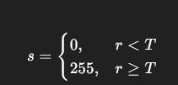
- Justification: Segmented the image into black and white. However, because the bullet was very small, this method did not yield clear results.

3.5 Contrast Stretching (Piecewise Linear)
- Formula:
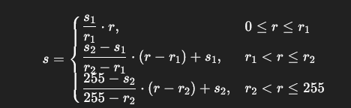
- Justification: Enhanced the global contrast of the image, though results were only moderate.

3.6 Histogram Equalization
- Formula:
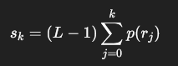
- Justification: Redistributes pixel intensities to improve overall contrast. The bullet became easier to identify due to global brightness adjustment.

3.7 Combination: Logarithmic + Contrast Stretching
- Step 1: Logarithmic Transform s1=c⋅log(1+r).
- Step 2: Contrast Stretching on s1​.
- Justification: The log transform enhanced low-intensity details, while contrast stretching boosted overall contrast. This combination gave strong results but required parameter fine-tuning.

4. Results & Analysis

4.1 Negative Transformation
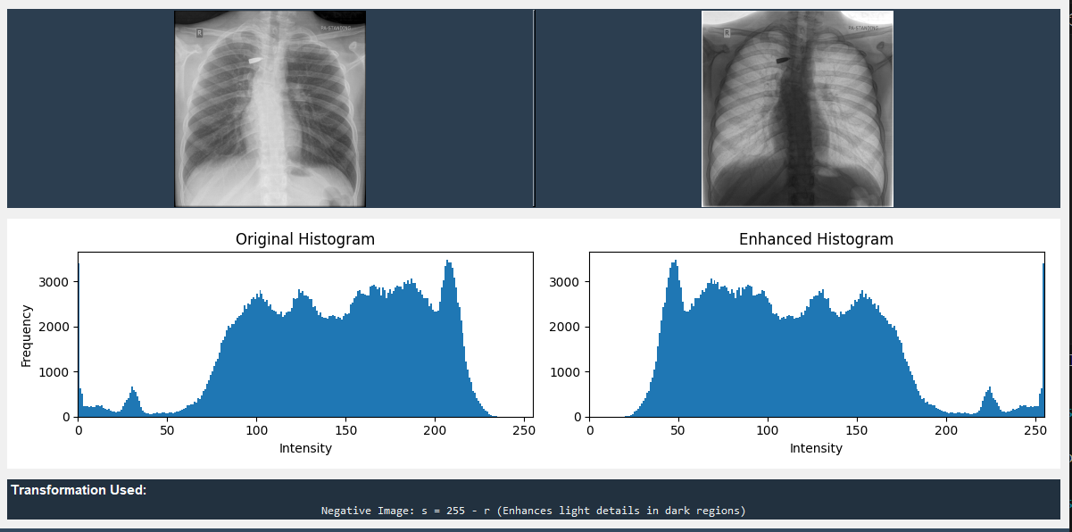
- Observation: Bullet appeared much clearer as it contrasted sharply against lighter tissues.

4.2 Logarithmic Transformation
- Observation: Helped reveal shadow regions but slightly compressed brighter areas.

4.3 Gamma Transformation
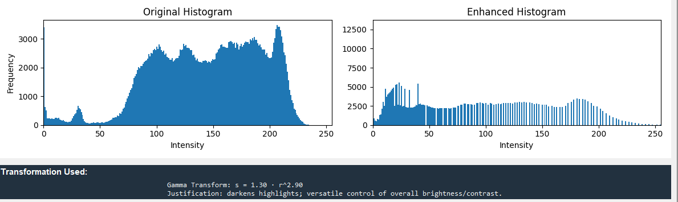

- Observation: With γ<1, bullet visibility improved greatly. With γ>1\, results worsened.

Thresholding
- Observation: Failed to isolate the bullet, as small object details were lost.
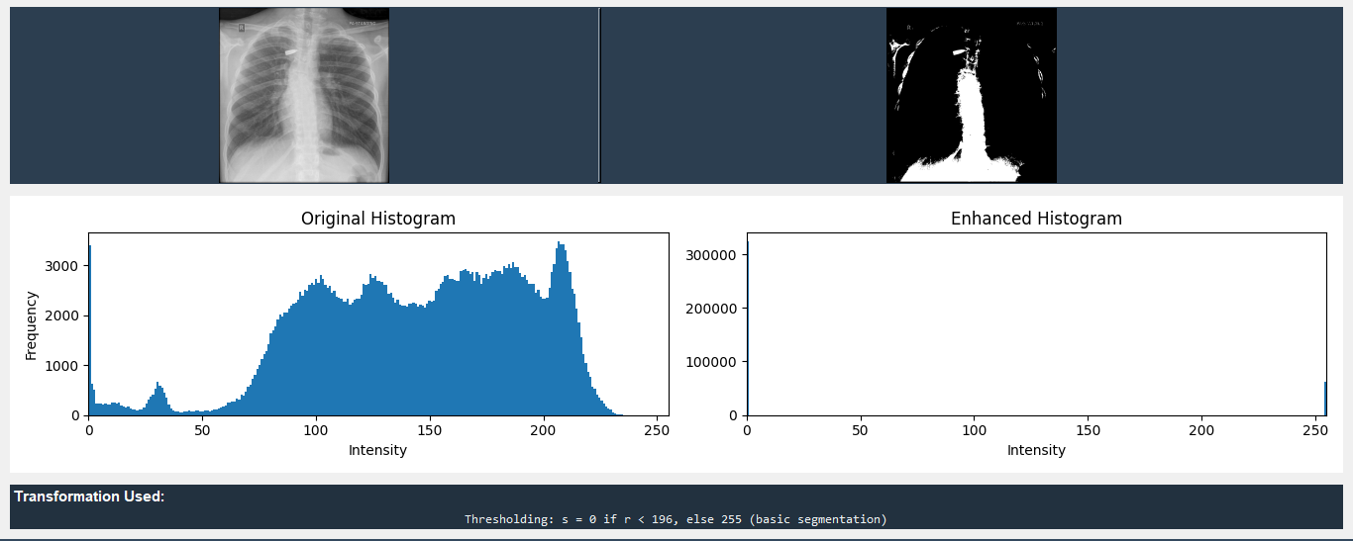



4.5 Contrast Stretching
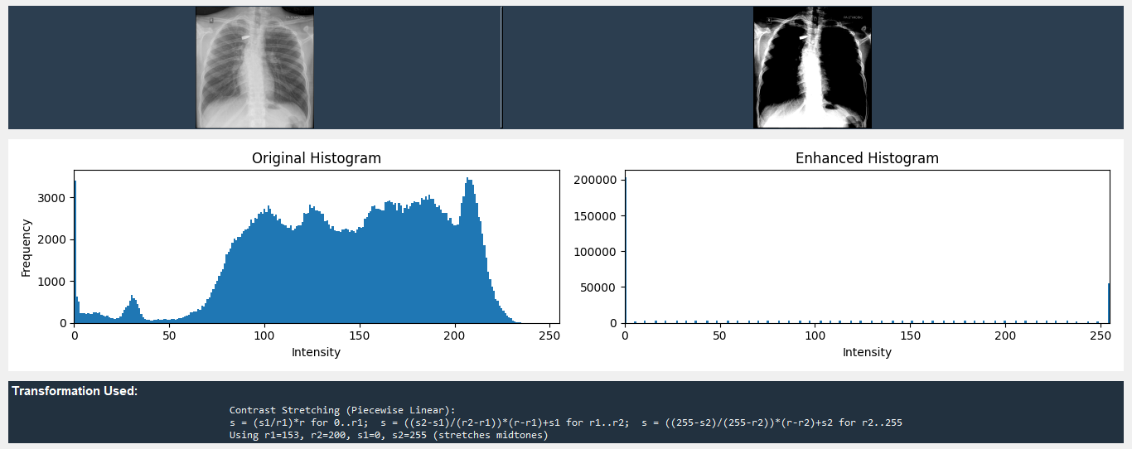
- Observation: Moderate improvement, but not as effective as Negative or Gamma.



4.6 Histogram Equalization
- Observation: Improved global contrast and made the bullet easier to detect, though sometimes over-enhanced surrounding tissues.

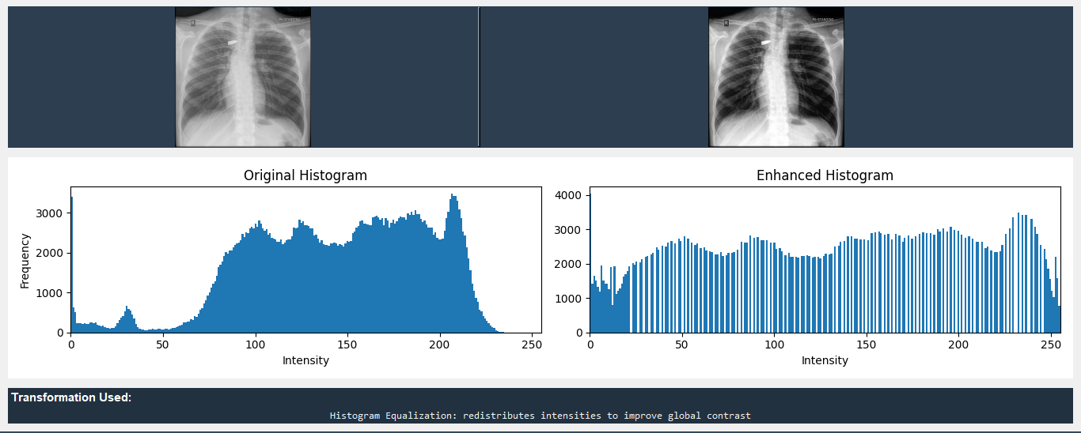

4.7 Log + Contrast Combo
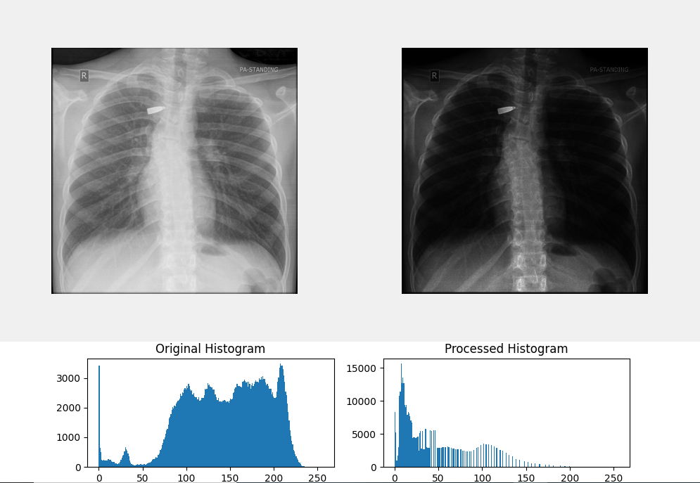
- Observation: Produced one of the best results by enhancing shadows and adjusting global contrast.
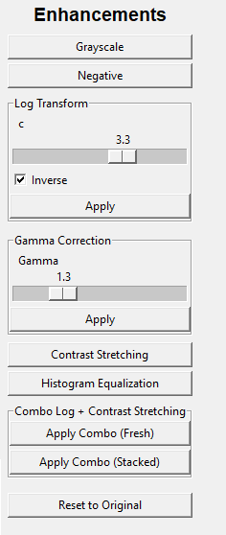

5. Critical Evaluation
- Most Effective Techniques: Negative and Gamma Transformations clearly highlighted the bullet.
- Least Effective: Thresholding, as it oversimplified the image and lost fine details.
- Combination: Log + Contrast Stretching produced strong results but required careful parameter selection.

6. Conclusion
Among all tested techniques, Negative and Gamma transformations were most effective in detecting small foreign objects such as bullets in X-ray images. Histogram Equalization and the Log+Contrast combo also provided significant improvements. Thresholding was not suitable in this context. Overall, image enhancement can greatly support medical diagnostics by making critical details more visible.

